H.T No
Regulations:
A22

Sreenidhi Institute of Science and Technology
(An Autonomous Institution)
Code No: 9CC05 Date:24-January-2025 (AN)

B.Tech II-Year II- Semester External Examination, January-2025 (Supplementary)
DIGITAL LOGIC DESIGN(ECE)

Time: 3 Hours Max.Marks:60

Note: a) No additional answer sheets will be provided.
b) All sub-parts of a question must be answered at one place only, otherwise it will not be valued.
c) Missing data can be assumed suitably.
Bloom's Cognitive Levels of Learning (BCLL)

Remember | L1 | Apply | L3 | Evaluate | L5
Understand | L2 | Analyze | L4 | Create | L6

Part - A Max.Marks: 6x2=12

Answer all QUESTIONS, EACH QUESTION CARRIES 2 MARKS.

 |  | BCLL | CO(s) | Marks
1 | Convert (675)₁₀ to hexadecimal form. | L2 | CO1 | [2M]
2 | Analyze the basic gates with their truth tables. | L2 | CO2 | [2M]
3 | Design 4x1 mux using 2x1 mux. | L3 | CO3 | [2M]
4 | Write a short note on classification of sequential circuits. | L1 | CO4 | [2M]
5 | Differentiate asynchronous and synchronous counters. | L2 | CO5 | [2M]
6 | What are PLDs ? | L1 | CO6 | [2M]

Part – B Max.Marks: 6x8=48
ANSWER ALL QUESTIONS. EACH QUESTION CARRIES 8 MARKS.

 |  | BCLL | CO(s) | Marks
7. | Explain about BCD, excess-3 codes and gray codes with an example. | L2 | CO1 | [8M]
 | OR
8 | - Convert the given POS expression in to standard POS Form f(A,B,C) = A . (A+B+C).  - Compute addition of (+112) and (-70) using 2′s complement. | L3 | CO1 | [8M]
9. | - Implement an XOR gate using NAND gate.  - Reduce the given function to minimum number of literals  Y(A,B,C,D) = ∑_{m} (1,4,6,9,10,11,14,15)+ ∑_{d}(7) | L4 | CO2 | [8M]
 | OR
10 | How is Quine-McCluskey Method different from k-map? Reduce the function using Tabular method F(V,W,X,Y,Z)= ∑(0,1,2,8,9,15,17,21,24,25,27,31) |  | CO2 | [8M]
11 | - Design a 2 to 4 Decoder with necessary truth table and logical diagrams.  - Implement POS function F= π ( 1,3,5,7) using 3x8 Decoder. | L4 | CO3 | [8M]
 | OR
12 | Explain about multiplexers and implement Combinational logic for the following function using 4X1 Multiplexer 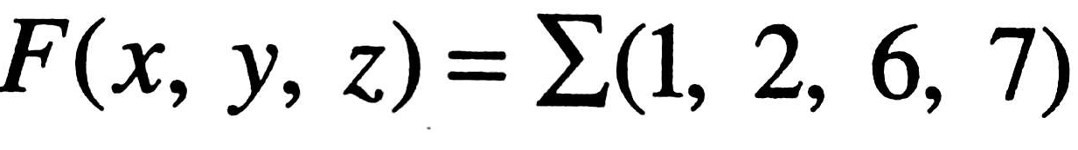 | L4 | CO3 | [8M]
13 | Discuss the steps involved in conversion of flip-flops, by using JK flip-flop realize D flip-flop. | L4 | CO4 | [8M]
 | OR
14 | - How are latches different from flip-flops discuss in brief?  - Derive the truth table and excitation table of SR flip-flop. | L3 | CO4 | [8M]
15 | Analyze the operation of 2-bit ripple up down counter using necessary input and output tables. | L4 | CO5 | [8M]
 | OR
16 | Examine the operation of data transmission in registers and delineate the serial –in serial-out shift register. | L2 | CO5 | [8M]
17 | Implement following functions using suitable ROM  F1 = ∑m(0, 1, 7)  F2 = ∑m(0, 3, 6, 7)  F3 = ∑m(0, 1, 3, 5, 7) | L4 | CO6 | [8M]
 | OR
18 | Explain about PLA and its General structure using an example. | L2 | CO6 | [8M]

-- 00 -- 00 –

